## Practical Task Answers

### Task 1

#### Summary

The following two websites analysed below are close in design to my proposal idea. They are both responsive to changes in screen size, and use block-like elements as their interactive components.

#### Site 1: Brittanica Quiz

Link: <https://www.britannica.com/quiz/what-do-you-actually-know-about-the-internet>

The different components of this website scale and reposition effectively, in accordance with whether it is viewed on desktop (Figure 1) or mobile (Figure 2), allowing for clear, organised, and non-cluttered viewing on each medium while maintaining key data across both.

In the desktop view, all the components of the navigation bar are in view, whereas in the mobile view, it is truncated. This is made up by the scrolling function, allowing each of the hyperlinks to be accessible by the user.

In the desktop view, the numbers representing the question, the score, and the timer countdown occupy space on the left side of the main content due to the greater longitudinal real-estate provided in this view. Meanwhile, in the narrower on mobile view, these artefacts take up the entire width near the top.

In the desktop view, the boxes containing the possible answers are evenly spread out in the 2x2 manner, while in the mobile view, they become stacked on top of each other as a singular column in a 4x1 hamburger-like fashion.

Where the mobile view falls short in horizontal size in comparison to the desktop view, it makes up for by utilising and expanding on the vertical size to store its components.

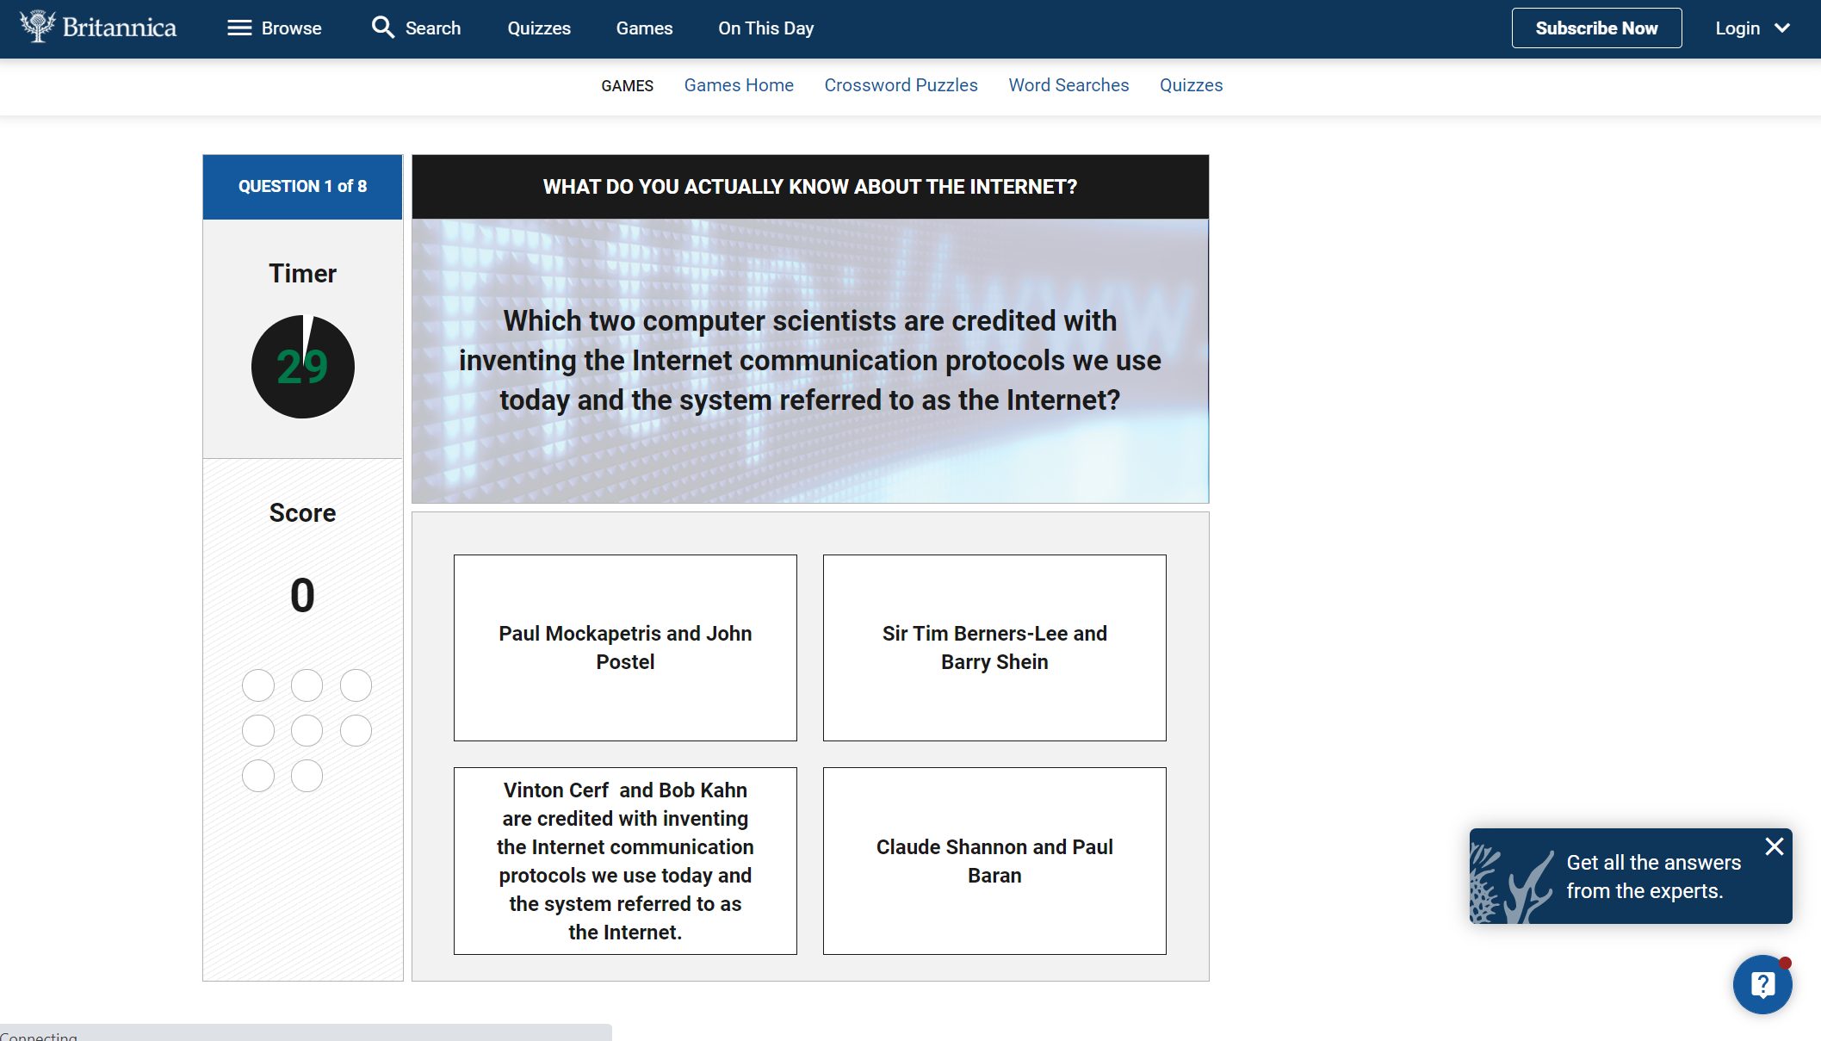

Figure 7: Desktop View of Britannica Quiz

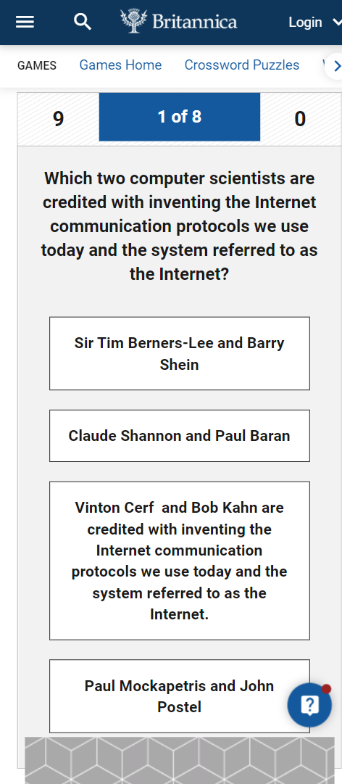 

Figure 8: Mobile View of Britannica Quiz - Top Figure 9: Mobile View of Britannica Quiz - Bottom

#### Site 1: Starting Blocks

Link: <https://www.startingblocks.gov.au/>

All of the elements in the body of this website are contained in coloured blocks. These blocks rearrange effectively in response to the changes in the display size.

In the desktop view (Figure 10), the blocks populate almost the entire page by utilising the greater width, fitting 4 blocks in each row. Depending on the screen resolution and zoom, little to no scrolling is required to access all the contents in the page.

Similarly, in the mobile view (Figure 11), the blocks also populate almost the entire page, but because of a smaller width, can only fit two blocks in each row, and compensates for the rest of the blocks not shown in the screen by introducing scrolling.

Meanwhile, the header and navigation bar in the mobile view are compacted into the same pane. Unlike the scrolling mechanism adopted by the Britannica Quiz website, the navigation bar of this website is invisible while in the main view, being only accessible by expansion of the 3-lined symbol.



Figure 10: Desktop View of Starting Blocks Website

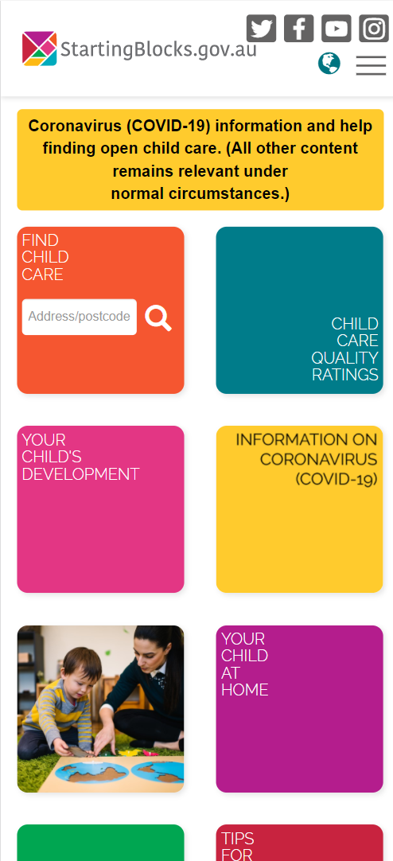 

Figure 11: Mobile View of Starting Blocks - Main Figure 12: Mobile View of Starting Blocks - Navigation Bar